Paper 1:

LEDs for lighting: Basic physics and prospects for energy savings

Bruno Gayral

Section 1. The goal of the article is to discuss the basic LED physics with emphasis on lighting applications. Section 2. The phenomena of electroluminescence is discussed, noting that traditional incandescent bulbs do not have electroluminescence properties, rather just light emission from heat. Electroluminescence is defined as the phenomena that occurs whenever electric current is directly responsible for light emission, although the paper does not go much more in depth. Then it goes on to describing the basic ideas behind semiconductors. Light emission through a semiconductor occurs when an electron in the conduction band is transferred to the valence band. In order to make a LED out of a semiconductor you need to “dope” this process, where doping is either adding more impurities to the conduction band, or removing most impurities from the valence band, essentially nullifying the insulator properties of semiconductors. Generally, the conversion from electric power to optical output for traditional incandescent bulbs is ~5% whereas the LED method allows for 100% conversion.

*Basic setup of LED/semiconductor*

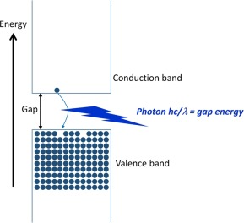

Section 3. During the production of LEDS many thought that GaN (Gallium nitride) type would be the ideal candidate, however crystals were never able to reach high levels of purity (still cannot to this day). The research on GaN LED’s was essentially declared dead before a new way to produce GaN crystals was discovered by (Akaski). Denoted as the MOVPE technique, it used varying types of crystals as well as radiation techniques to demonstrate LED. However, is was only set to one emission color and could not be created on an industrial scale. Nakamura then introduced the two flow MOVPE technique, as well as showing that mg doping could be done with simple thermal annealing (instead of radiation). After this came more small developments throughout the 90’s, but through these breakthroughs the “efficient Blue LED” was created and became a viable industrial commodity.

Section 4. The invention of the efficient blue LED was awarded the Nobel Prize for its potential benefit to mankind. This section details the economic benefits of the LED, how they are becoming more viable every year and the technical benefits that LED’s have over traditional means. Good section for statistics.

Graph illustrating cost over a few years for domestic lighting (3hrs a day)

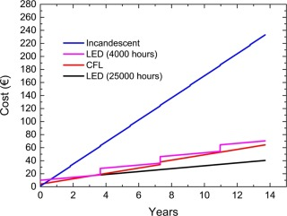

Graph illustrating cost over a few years for industrial lighting (12 hrs a day). Incandescent *so* expensive its not included on this graph.

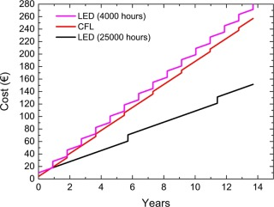

Paper 2:

Visible electroluminescence from porous silicon

Koshida and Koyama

Article is discussing the electroluminescence (EL) from the “spongy” phase (PS) of silicon. Mainly will be used by me to better understand the process of electroluminescence. Using a very large surface area to volume layer, moderate current densities were ran through the PS layer. The question is, can electroluminescence be achieved through PS based devices? The paper confirms that anodized PS excited with UV light shows visible photoluminescence (PL).

The paper then describes the process of obtaining this result. To begin they did surface etching, anodization and drying. Then put the silicon sample in a vacuum chamber, and semitransparent gold films were laid across the sample. Then a current was run through the sample and the “current-voltage” characteristics were measured under a reverse biased process. Then the relationship between current density and EL intensity was measured. And finally, the EL spectra were measured by “conventional’ methods and were graphed in various figures.

The final section details more specific details of the experiment. The Current density was measured at 370 mA, the EL spectrum was found to be 680 nm (short of the 700 nm of PL). The width of the EL band was 0.32 eV and the integrated quantum efficiently was 10^-5 %. Check this section for the minute details of the experiment. The conclusion states that EL emission at room temperature was obtained from the PS-based setup. The result indirectly proves the quantized features of the PS of silicon. The author states that more detail experiments are required to more fully understand PS and EL properties.